🔹 Focal Loss (Variant of cross-entropy, designed for highly unbalanced datasets):

Formula: 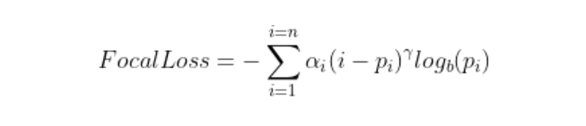
where:

- “pi“ is the correct predicted probability (i.e., p if the label is 1, 1−p if the label is 0),
- α ∈ [0,1] is a class-balancing factor,
- γ ≥ 0 is the “focusing” parameter (typically 2),
- (1−pi) ^γ reduces the weight of easy samples and increases that of difficult samples.

🔹 Dice Loss:

Formula:
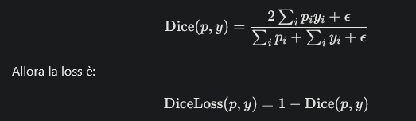
where:
- pi are predictions
- yi are labels
- ϵ steadiness factor to avoid zero division

Derived from the Dice coefficient (like the IoU), it measures the overlap between prediction and ground truth.
It works well with unbalanced masks because it evaluates how well the areas (or lines) match rather than counting only pixels.

Practical effect: forces the model to maximize the overlap between the predicted line and the ground truth.

🔹 Distance Map BCE (DistanceMapBCE)

The Improved Distance Map Loss (Davari et al., 2021) is used to give more weight to pixels close to the front line, reducing the influence of the background that would otherwise dominate the loss.
It works by creating a weight map derived from the distance from the front line and multiplying the network's predictions by it before calculating the loss.

- Front Dilation

The front-line mask y (thin, 1 pixel) is dilated with a kernel w×w:
This "widens" the front so that there is a band of pixels around the line.

- Distance Transform (EDT)
The Euclidean Distance Transform is calculated on the dilated front:
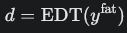

- Relaxation Factor Scaling
The distance is divided by a parameter R (relaxation factor), and passed to a sigmoid:
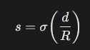

- Normalization
Scale s to bring it into the interval [0,1].

- Combination with the background
The dilated front yfat is taken, inverted, and multiplied by a factor k.
Finally, it is added to the previous term:
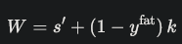
W is the final weight map.

- Multiplication of predictions
The sigmoid prediction of the network p is multiplied by W:

- Final loss
In the work by Davari et al., cross-entropy was used.
In Calving Fronts, Dice loss is used (more suitable for unbalanced datasets):
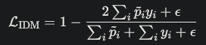

To summarize:
- Dilation + EDT + sigmoid → creates a band of increasing importance around the front.
- Addition with the k term → prevents the background from being completely ignored.
- Multiplication of prediction × weights → forces the network to focus on the precise positioning of the line.
- Dice Loss → better handles the huge imbalance between a few pixels of the front and millions of background pixels.

